
DATA PROTOCOL RFO
PROTOCOLE DE DONNEES
June 11, 2024
wcs
RFO

Contents
RFO DATA PROTOCOL 2
1. Introduction 2
1.1. Why is it Important to Formalize a Data protocol? 2
2. Data Management Protocol collaborators 2
2.1 Dataset description 3
3. Data Collection 3
4. Data collection Tools 3
4.1. DATA collected Sample table 4
4.1 Data Flow 5
3. DATA PROCESSING 6
Materials and Methods for data processing 6
3.1 Estimated volume of data 6
3.2 Meta data description 6
3.3 Meta data standards 6
3.4 Data format 6
3.5 File management 6
3.6 Deliverables expected from this dataset 6
4. Data review process and storage 7
5. DATA ROLE AND REPSONSABILITY 7
6. Data Quality 8
6.1 Data quality check 8
6.2 Conformity of Data 8
6.3 Consistency 8
6.4 Accuracy: Ensure data reflects reality. 8
6.5 Eligibility 8
7. DATA SHARING AND DIFFUSION 10
7.1 Durring the Project 10
7.2 After the project 10
8. DATA ARCHIVING AND PRESERVATION 10
8.1 Storage and saving 10
8.2 Data to be destroyed 10
Name of person in charge of archiving and preservation 10
9. DATA STORAGE 10
10. DATA VISUALISATION 11
10.1 Visualization tools 11
POWERBI ROLES 15
11. UPDATE FREQUENCY 15

RFO DATA PROTOCOL

Introduction
A data protocol is a plan that outlines how an WCS will collect, manage, and utilize data to meet its business goals. The roadmap defines the steps required to turn data into actionable insights and outlines the key decisions and investments required to achieve success.

Why is it Important to Formalize a Data protocol?
Formalizing a data strategy roadmap is critical for WCS looking to effectively leverage its data to achieve its business objectives. Here are some reasons why it is important to formalize a data strategy roadmap:

Data Management Protocol collaborators
- Meal team
- Database manager
- IT
- Meal Lead
- Program
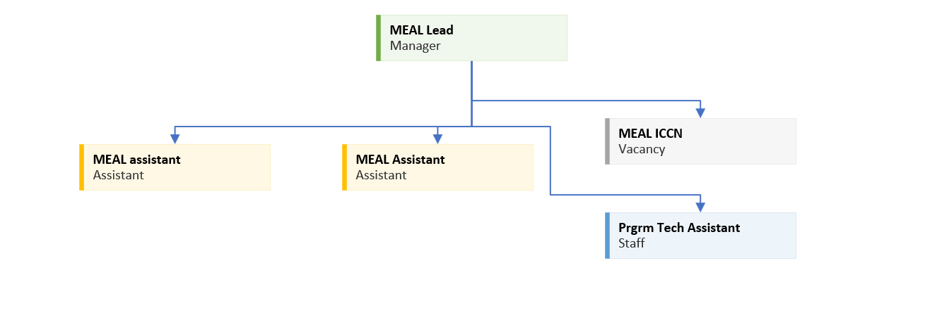
Fig 3 : org structure

Dataset description
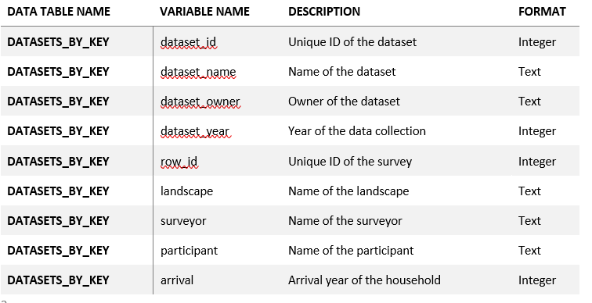
Fig 4 : data set

Data Collection
Data collection will occur in private spaces where only the WCS team members and participants are present. If others enter the space, the researcher will stop the interview/focus group until the person leaves.

The research team will record no identifiable data – such as names, ages, addresses, contact information. A code will be utilized to match the research data with any relevant case files (stored by the program team separately from the research). The research team will never have access to names, exact birthdates, phone numbers or addresses. The code linked data provided by the program team will instead be relevant details about the incident of GBV (e.g., type of violence, perpetrator, date it occurred, and age of survivor). Please see the “Unique Identifier Codes (UICs)” section below for more details on data coding used to protect participants’ confidentiality.

Focus group discussions and key informant interviews will only be recorded if consent is received. These recordings will be transcribed approximately one month after data collection is completed. Upton transcription, all original audio recordings Will be deleted.

Data collection Tools
MEAL is currently using both electronic and manual data collection tools for the ORW program.
Electronic | Comment | Used by | Manual | Comment | Used by
Kobo collect | Storage issue | - BNS  - NRG  - Program activities  - Graduation  - Legal
SMART | Excellent | LAB
Comcare | Indirect used | Mercy corps TUJENGE
Microsoft form | Piloting | Staff survey and potential replacement of Kobo Collect
Earthranger | TBD | Integrated with Smart
IMET |  | MEAL
Tab 1 : data source

DATA collected Sample table
Bellow you can see, example of OWR data table from different sources.
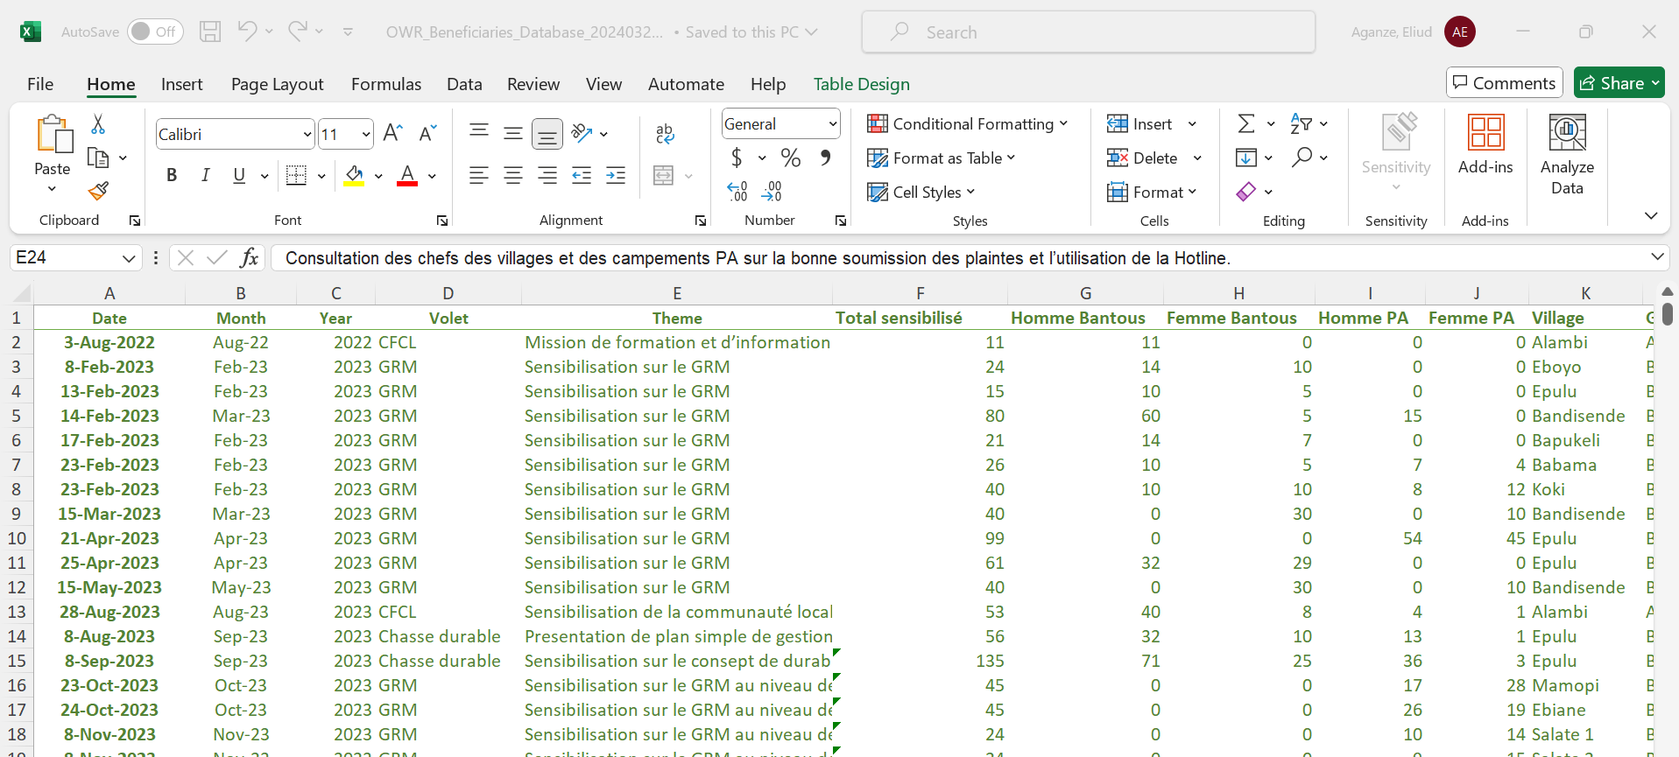
Fig 5 : data table

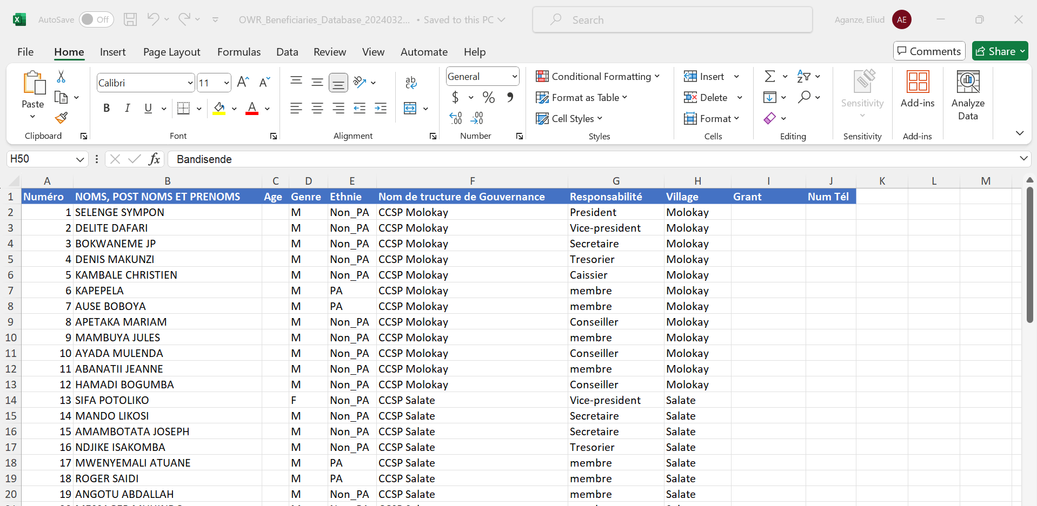
Fig 6 : data table 2

4.1 Data Flow
This diagram illustrates how data is collected, process stored and visualized.
Information is collected using tools like, KOBO Toolbox, Comcare, Liste de presence, PV, Smart and other tools and then downloaded in excel sheet.

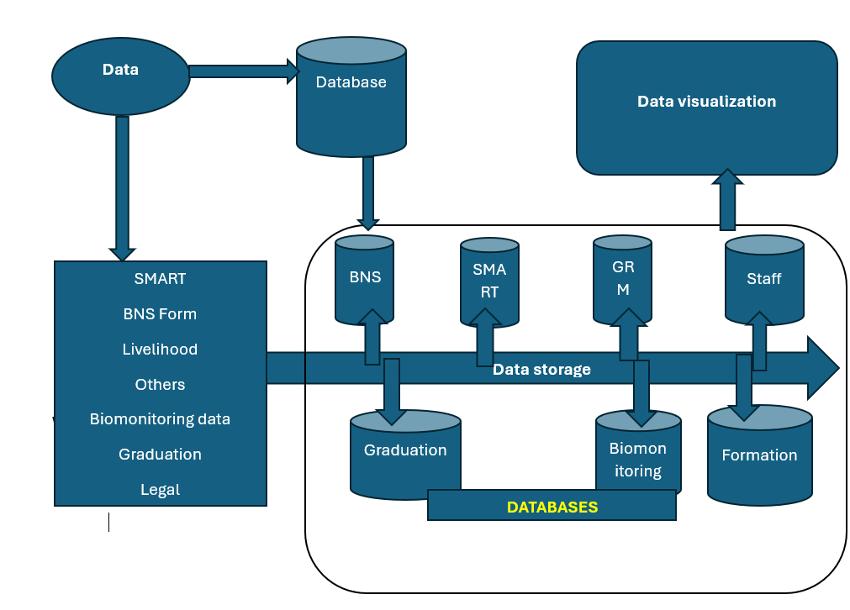
Fig 7 : data flow diagram

3. DATA PROCESSING

Materials and Methods for data processing
Data will be collected through Kobo collect on tablets, which will ensure data consistency within and between sites. The use of Kobo collect SMART, Comcare will mean that very little primary data processing is needed. Data will be directly uploaded from Kobo collect and stored and analysed on an online database hosted by WCS.

3.1 Estimated volume of data
Between 50 and 1000 Mo per month

3.2 Meta data description
Metadata are collected automatically by kobotoolbox for each survey:
- Deviceid: unique identifier of the device (tablet)
- Start: date and time of the beginning of the survey
- End: data and time of the end of the survey
- And smart

3.3 Meta data standards
NA

3.4 Data format
The data format is generated though data collection tools as input or output data such as Kobo toolbox, Comcare, SMART, Asana, Excell etc.
- XLS
- Excel
- CSV
- Jason
- XML
- Geodata (shp,)
- SQL

3.5 File management
kobo toolbox is storing and managing the versions of the forms.

3.6 Deliverables expected from this dataset
Online NRGT database, Smart report, Powerbi report, Dashboard, Excell report, NRGT reports per site

Data review process and storage
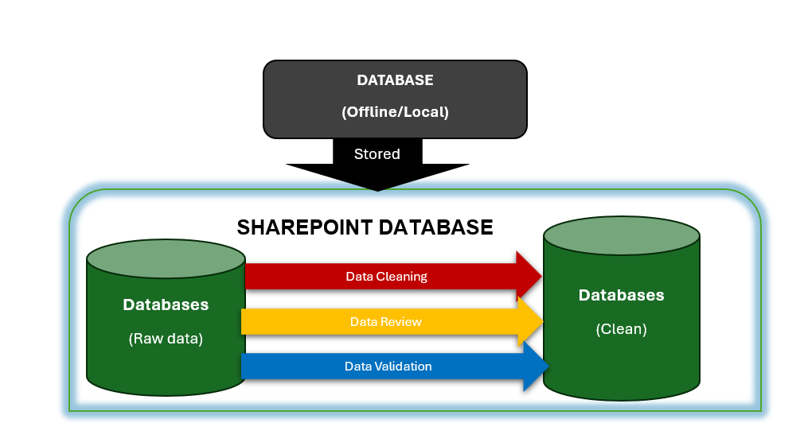
Fig 8 : database clean and raw data

- DATA ROLE AND REPSONSABILITY
The diagram below shows the role in reference to the data processing lifecycle showing members responsible for at each stage of the process.

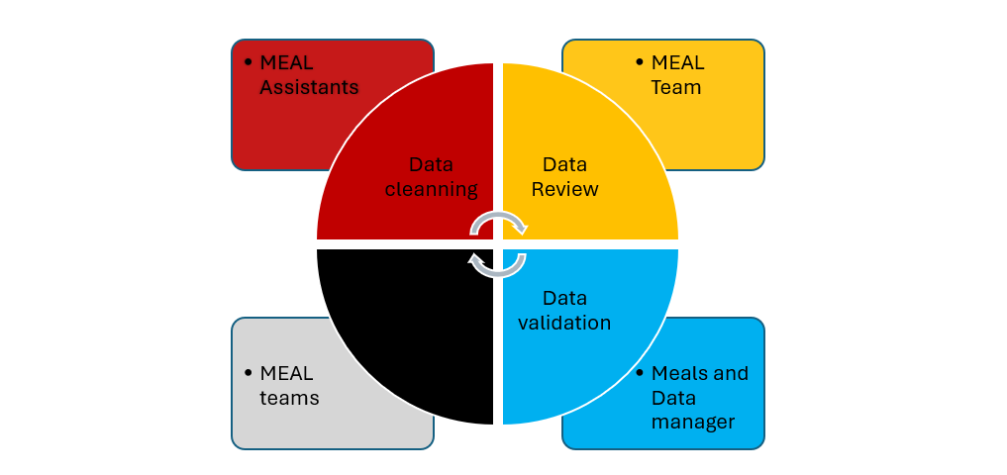
Fig 9 : role in each process

Table with Roles
Process | Access | Storage | Responsible
Data check/cleaning | Full | SharePoint Raw data | MEAL Officers
Data Review | Full | SharePoint Raw data | MEAL Officer & Data manager
Data Validation | Request | SharePoint Raw data | Data manager
Approved data | Full | SharePoint Clean data | All meal staff
Tab 2 : access roles for validation process

Data Quality
This process outlines general guidelines for data collection, specific procedures for ensuring data quality and the roles and responsibilities of MEAL staff.
Dos and Don’ts
Below are some general but essential guidelines for all data collection.

DO
- Introduce yourself and put participant at ease
- Ensure privacy and confidentiality
- Be clear and ask for clarification
- Be sensitive to personal questions
- Discuss next steps in the process
DON’T
- Falsify any data, or complete information for participants
- Influence participants réponses
- Leave things blank or incomplete
- Let participant leave without a final check
The MEAL Team should review forms with a focus on the following:

Data quality check
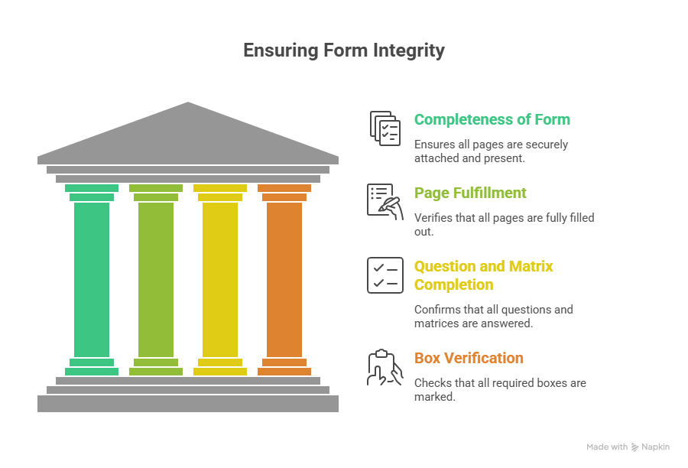
- Completeness of Form: Are all the pages stapled properly?
- Are all the pages of the form filled out?
- Are all the questions and the matrixes filled out?
- Are all the required boxes checked?
- Does the form have a password?

6.2 Conformity of Data
- Is all the data entered in a conforming manner?
- Are all the currency numbers written in dollars or Francs etc.?

6.3 Consistency: Look for data values that give conflicting information.
- Are all the data values consistent? month etc. Someone born in 1869. Record any problem on the DAF
- Do some values look out of place?

6.4 Accuracy: Ensure data reflects reality.
- What data is inaccurate?

6.5 Eligibility
- Is handwriting clear, eligible and readable? And does the form if examined as a whole make sense?

After the M&E team collects all the DAF information it is summarized in the Data Audit Report (see below). The report will provide an outline of what the M&E team needs to focus on. It identifies the data problems, a plan for correcting the problem, staff responsible, and the required timeline.

All the change will be recorded on the Data Auditing Form

Data Auditing Form
Reviewed Form | Platform | Data reviewed | Problem identified | Solution | Data collector
Form xxx | Kobo
Reviewed by  Name:  Role: |  |  | Signature
Tab 3: Audit data review

The M&E Manager is responsible for following up on these trainings and filing of the reports. The DAF and the Data Quality Audit Report reports should be compiled for records and sent to M&E Specialist quarterly. Such reports will help in detecting major problems areas in our data tools.

DATA REVIEW REPORT
Item | Problem | Correction plan | Staff responsible | Timeline
Date of Follow-up :
Signature :
Tab 4: data review report

FORM REVIEW CHANGE

FORM REVIEW CHANGE

Platform | Form id and name | Current form version | Review version id | Date of review | Change made
Name:
Role:
Tab 6 : form review change

DATA SHARING AND DIFFUSION

7.1 Durring the Project
Data Is available to other WCS partners via the WCS website and available for WCS user via WCS platforms (teams, SharePoint, google drive, internal databases).

7.2 After the project
Where data are made available to the internal WCS database, they will be made freely available to all WCS staff and external user up on granted request by WCS. Please contact MEAL Team for further information.

DATA ARCHIVING AND PRESERVATION

8.1 Storage and saving
Site based storage and cloud-based storage through WCS Intranet

8.2 Data to be destroyed
Will depended (ToBeDetermine) reference to WCS data protection policies

Name of person in charge of archiving and preservation
Archivist or any designated staff will be in charge of archieve physical/paper based data according WCS policies and for electronic data MEAL team will be in charge of the process with collaboration with IT.

DATA STORAGE

Data storage access right

Roles | Data Entry/Check |  |  | Data validation |  |  | Data storage |  |  | Data visualization
 | Read | Write | Edit | Read | Write | Edit | Read | Write | Edit | Read | Write | Edit
MEAL assistant | X | X | X | X | X |  | X | X | X | X
Data manager | X | X | X | X | X | X | X | X |  | X
IT / |  |  |  | X | X | X | X | X | X | X | X | X
Meal lead |  |  |  | X | X | X | X | X |  | X | X
Tab 7 : data storage right

Task | MERL Manager | MERL Data Collector | Social Empowerment Manager
 | MERL Coordinator | External Data Collector | Program Manager
View all group and participant data
Enroll new participants (collect intakes)
Collect baseline, endline, GFU1, GFU1, MEP data
Change group status from “Not in use” to “Enrolling”
Change group status from “Enrolling” to “Active”
Edit group information
Edit participant information
Change participant status from “Active” to “Dismissed”
Change group status from “Active” to “Graduated”

SharePoint Access right

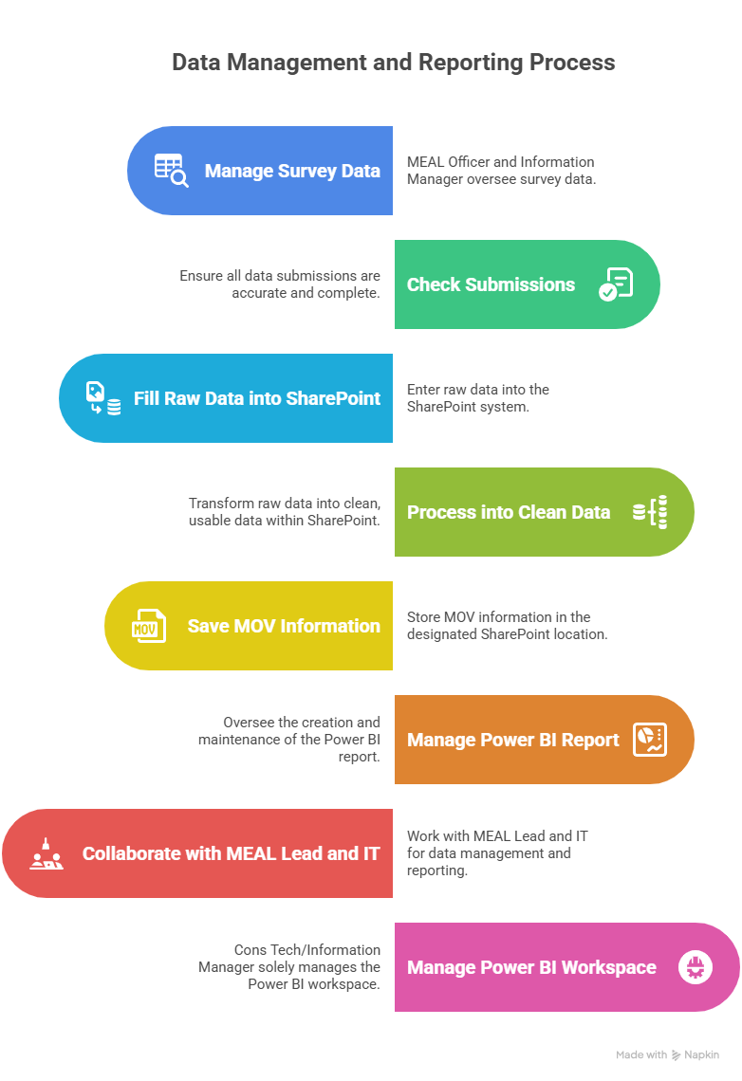

Source | Staff | MEAL assistant | Database manager | MEAL Lead | IT/
Survey form | x | X | X
Survey data |  | X | X | X | X
Raw data |  | X | X | X | X
Clean data |  | X | X | X | X
SharePoint MOV |  | X | X | X | X
Powerbi Report |  | X | X | X | X
Powerbi workspace |  |  |  |  | X
Tab 7: overall access level

DATA VISUALISATION

Visualization tools
What is Microsoft Power BI?
Power BI (or Power Business Intelligence) is a data visualization and business intelligence platform created by Microsoft. Its main purpose is to help users gather, analyze, and visualize data to see the results of the marketing activities and make decisions about the next steps.
With the help of this tool, you can upload raw data from various sources, such as CSV files, spreadsheets, databases, cloud services, and apps, and then transform it to create interactive reports and dashboards. These reports show data in an easy-to-understand way, helping companies deal with complex information.

Other tools
- Tableau
- Excell dashboard
- Excell Pivot
Why power BI
The choice of is motivate by the fact that integration of powerBI with WCS Microsoft subscription under one platform.
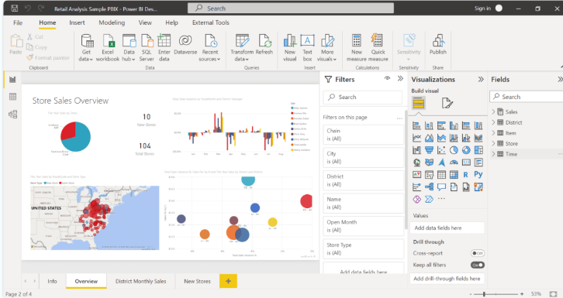
Fig 10: powerbi interface

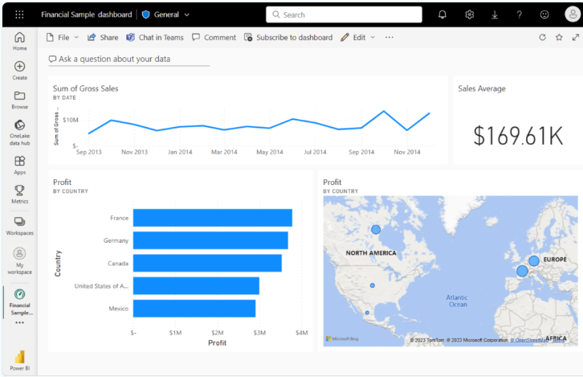
Fig 11: powerbi workspace online

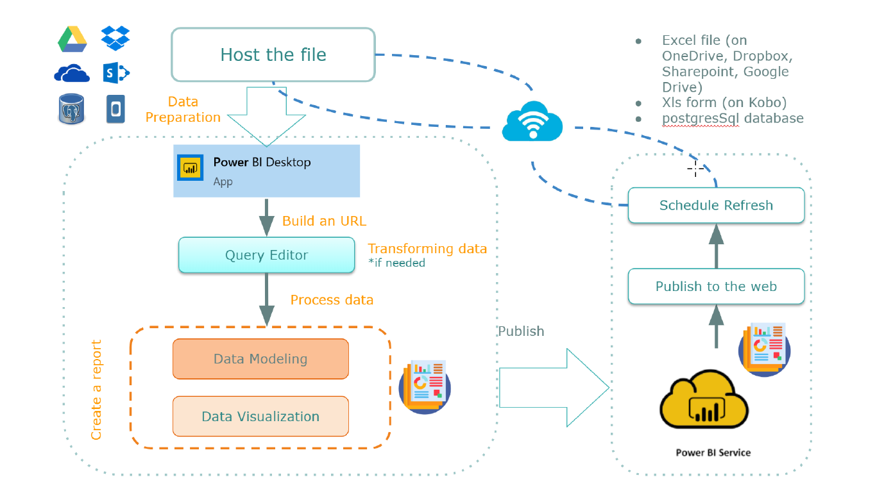
Fig 12 : Powerbi process

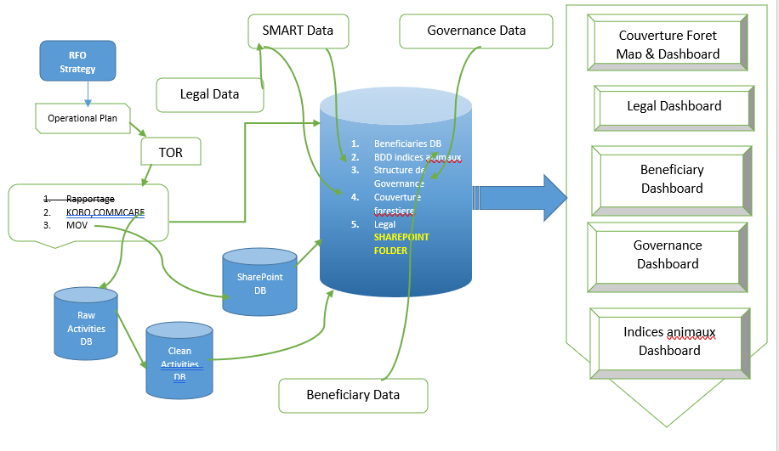
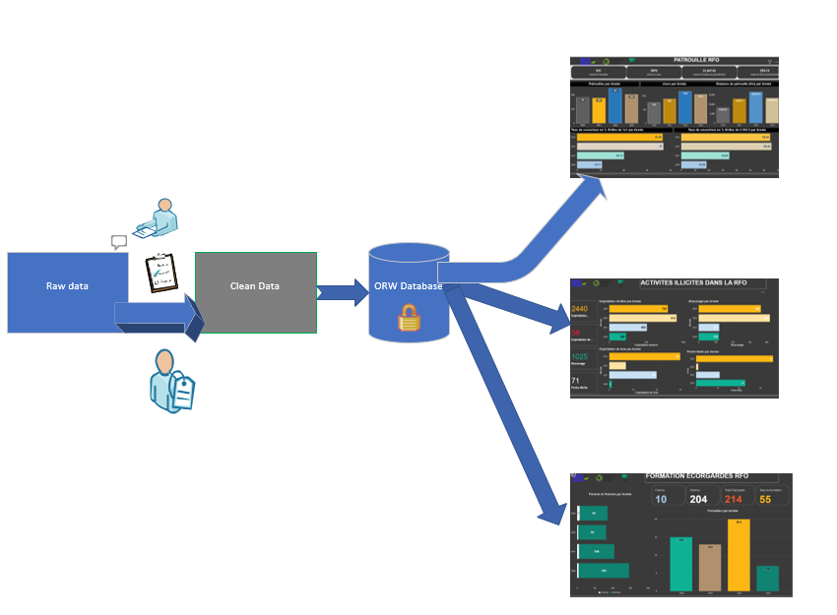
Fig 12 : data process and visualization

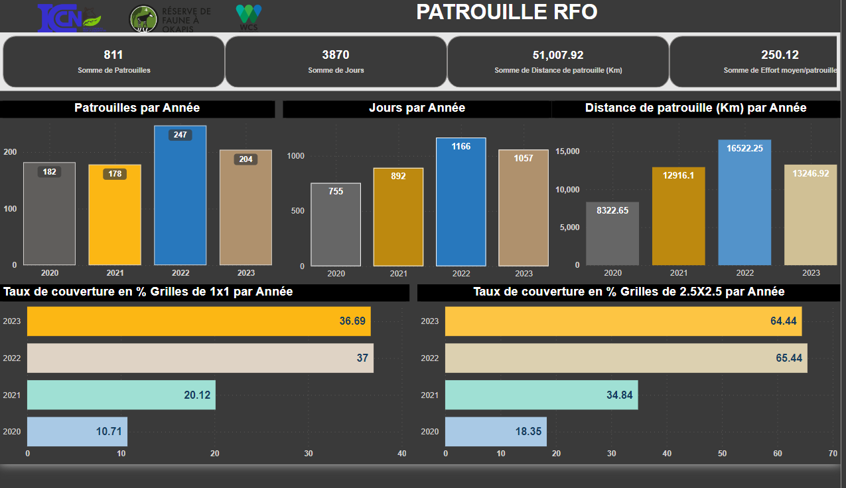
Fig 13 : Dashboard

POWERBI ROLES
1. Power BI Viewer role
As is self-explanatory by the title of this Power BI role, these kinds of users can view and interact with reports and dashboards without changing their contents. They have the lowest level of control over the data and the report.

2. Power BI Contributor role
Apart from being able to view and interact with reports and dashboards, this user type goes a step further by being able to create, edit, copy, and delete items in a Power BI workspace, publish reports, schedule refreshes, and modify gateways.

3. Power BI Member role
As with the contributor user type above, this user type can do all that the preceding user types can do. In addition, the member user type can also feature dashboards on the service, share items, allow others to reshare items, and publish or republish. This role can also add other users to the viewer or contributor role.

4. Power BI Admin role
This user type can carry out all functions of the previous user types as well as add and remove users, including other admins.

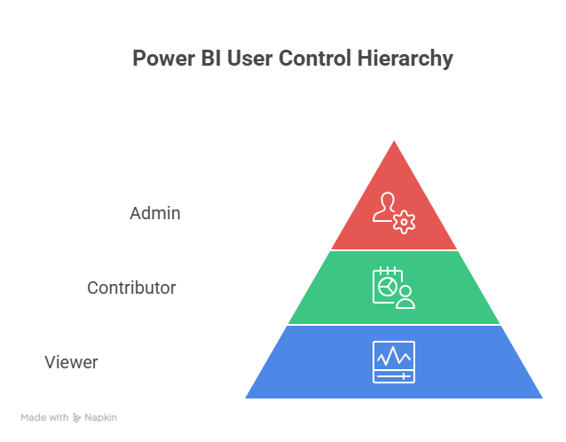

 | View | Contribute | Member | Admin
Staff/Everyone | X
Program staff | X
MEAL staff | X | X | X
Data manager | X | X | X
IT/…... | X | X | X | X
Tab 8: powerbi access

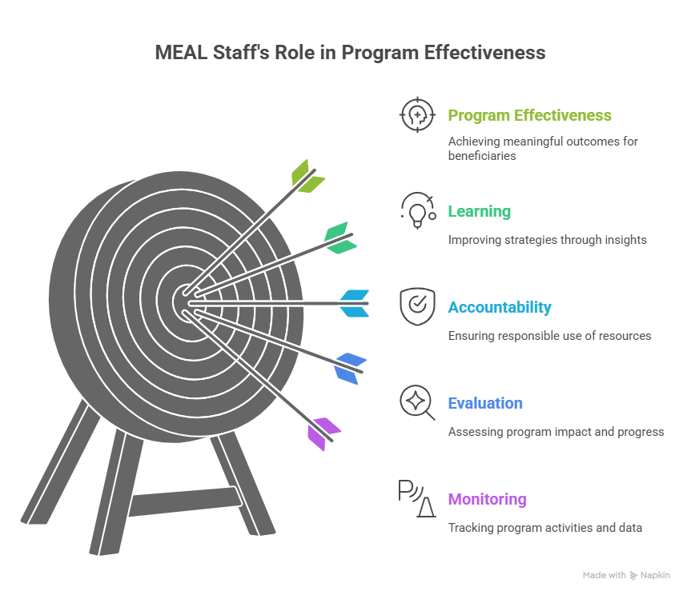

UPDATE FREQUENCY
Data Type | Frequency | Staff
SAMART | Trimestral | MEAL Assistant
Graduation
Training/Formation
GRM

Tab 9: update data

